FORMAT FOR SUCCESS STORY

 | Name of the farmer | Sri Ramnath Prasad
 | Name of the grassroots innovation/Venture/innovative approach developed by the farmers | Off season watermelon changes life of farmer
 | Address | S/o Late Ram Chandra Mahto,  Vill-Chaknawada, Block- Barh, Dist.-Patna
 | Mobile number | 8809998919
 | Annual turnover | 3,00,000.00
 | Description of the innovation | para I: socio-economic background of the innovator:  Sri Ramnath Prasad belongs to a medium family. He has only 4 acre of land in which he grows vegetables and sell his vegetable in local market of Barh. He has one small polyhouse and two cows. He is always in contact with KVK, Barh, ATMA, Patna and Different wing of agriculture department. He undergone training at Palandu (Jharkhand) and Varanasi (U.P.).
Para II: What specific situation/problem compelled farmer to innovate. If it was an accidental innovation what event led to innovation?
As Mr. Prasad have only 4 acre of land it was quite impossible to feed his joint family having 12 members. For getting more income out of the area available for farming he planned to do additional agricultural work quite different from others. In this regards he made an effort for the cultivation of off season watermelon in this area.
Para III: Description of the actual innovation
In Diara area of Patna district watermelon is produced in summer and the farmers do not get reasonable price in the season.For fetching more income Mr. Prasad consulted KVK, scientist for the remedial suggestion. KVK, scientist suggested him to grow off seasons watermelon.He started growing off season watermelon in a very small area (5 Katta)in the month of February 10th and started harvesting from second week of April. Within two months April and May he earned Rs. 52,000 as net income. The average price of watermelon was Rs. 30 / kg.
Para IV: what changes the innovation has bought in terms of costs, benefits, savings or any other aspects
For off season watermelon he spent only Rs. 1000 for seed, Rs. 3000 as labour cost and Rs. 4000 in other expenditure in 5 katta of land.
Item | Cost (Rs.) | Production  (Kg.) | Return (@ Rs. 16per Kg.) | Net return
Seed | 1000.00 | 2000 | 320000.00 | 312000.00
Labour | 3000.00
Others | 4000.00
Total | 8000.00 | 2000 | 320000.00 | 312000.00

Para V: What the innovator wishes do in future.
Sri Prasad has planned to grow watermelon in larger area during next year for fetching more income.
Para VI: Innovators message to the scientists and farming communities
Sri Prasad expects from scientific and farming community to promote planting off season watermelon in larger area for its supply to different district of state and finally income of the farmers will be doubled.
 | Award | 1 First prize winner in papaya production by Department of Agriculture in 2011  2 Best vegetable grower by ATMA, Patna (Govt. Of Bihar)
Compiled by-
Brajesh Patel
Mob- 9234535651
Krishi Vigyan Kendra, Barh, Patna
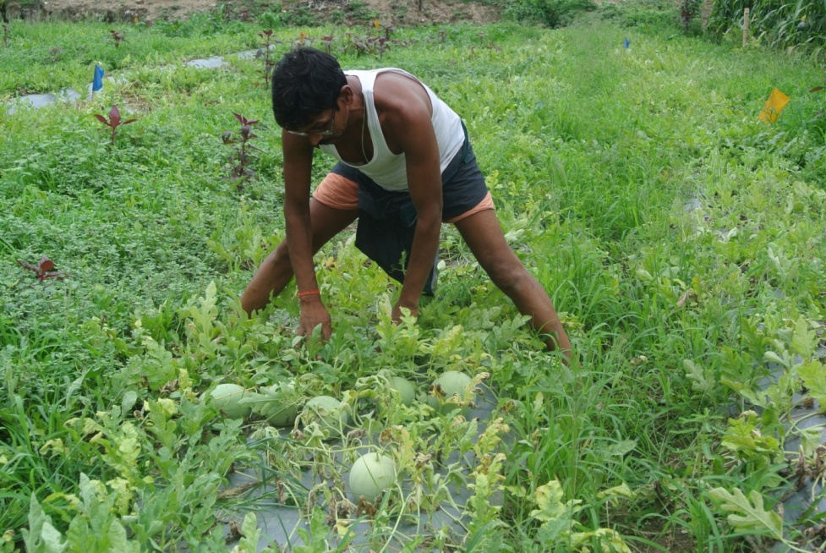

Sri Ramnath Prasad engaged in plucking the watermelon

