FORMAT FOR SUCCESS STORY

 | Name of the farmer | Sri Shiv Shankar Prasad
 | Name of the grassroots innovation/Venture/innovative approach developed by the farmers | white milky mushroom step towards livelihood upliftment
 | Address | S/o Late Kailesh Mahto,  Vill-Chaknawada, Block- Barh, Dist.-Patna
 | Mobile number | 9199497189
 | Annual income | 4,60,000.00
 | Description of the innovation | para I: socio-economic background of the innovator:  Sri Shiv Shankar prasad is a marginal farmer. After division of land among his three brothers he has only 7 katta of land. He has graduated from A. N.S. College, Barh and engaged himself in local politics. As the financial situation was not good to run his family, he started vegetable production by hiring land on lease. It was his dream to do something new in the field of agriculture. He visited KVK and got the training on mushroom production. After getting training he started the production on oyster mushroom. He was earning only 1-2 lakh rupees a year.
Para II: What specific situation/problem compelled farmer to innovate. If it was an accidental innovation what event led to innovation?
The income of Sri Prasad was too mere to meet the requirement of family survival. He constructed a mushroom shad of 70 x 30 feet and started the production of mushroom. By increasing the area of mushroom production the income was not sufficient as there was too much lowers in summer.

Para III: Description of the actual innovation
He tried to grow white milky mushroom and got failure so many times. Lastly he arranged the facility in the mushroom shad for the production of white milky mushroom by providing exhaust fan, wetting the shed by dripper and fogger locally designed by assembling different components. He started producing milky mushroom and succeed.
Para IV: what changes the innovation has bought in terms of costs, benefits, savings or any other aspects
Before the innovation:-
Cost of production per Kg of mushroom Rs.-35
Production: 1000 Kg
Cost of production for 1000 Kg.-35000.00
Sale price: Rs. 150.00/Kg.
Return: 1,50,000.00
Return: 1,15,000.00
After the Innovation:-
Cost of production per Kg of mushroom Rs.-35
Production: 4000 Kg
Cost of production for 4000 Kg.-1,40,000.00
Sale price: Rs. 150.00/Kg.
Return: 6,00,000.00
Net return: 4,60,000.00
Para V: What the innovator wishes do in future.
Sri Prasad is planning to produce round the year irrespective of stressed condition of climate.
Para VI: Innovators message to the scientists and farming communities
Emphasis to be made to grow white milky mushroom in larger area involving a number of farmers coming from different economic status.
 | Award | 1 Best Innovative farmer by BAU, Sabour 2012  2 Best vegetable grower by Deptt of Agriculture govt of Bihar
Compiled by-
Rajeev Kumar
Mob- 9835133147
Krishi Vigyan Kendra, Barh, Patna

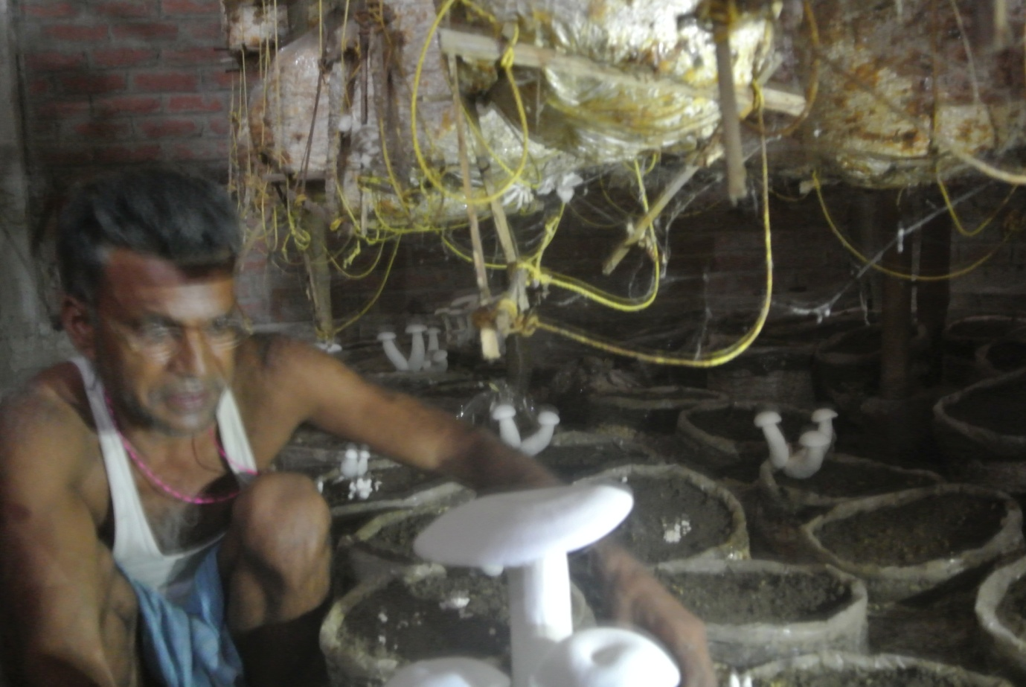

Sri Prasad engaged in mushroom production
